Lab report 3: 202/03/27

* In the first task I learned nothing new. Just opened and showed an image by its path.
* 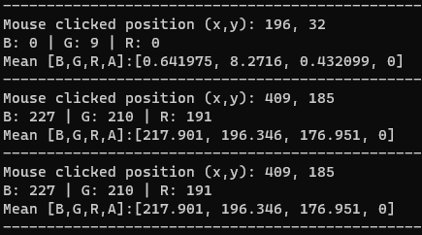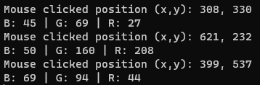In the second task I learned how to implement a mouse callback function. And get the x and y of the clicked position and print the BGR values for that point.
* 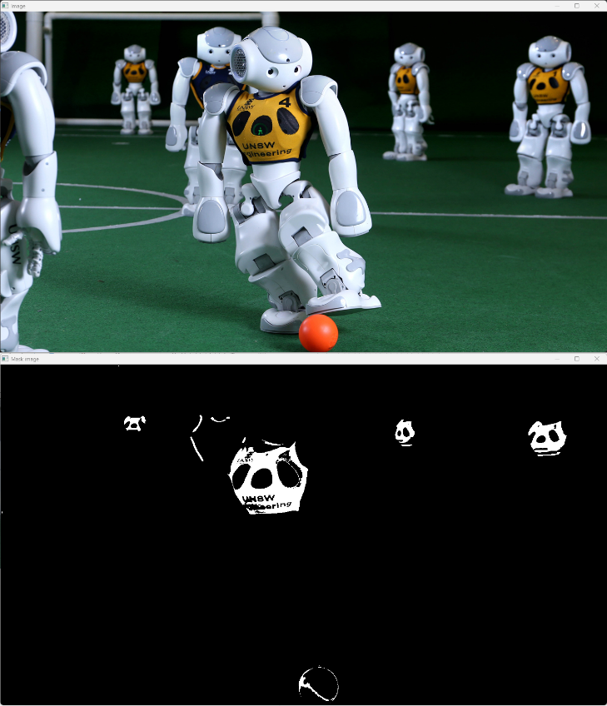In the third task I expanded the second task and added the mean value for each color for the 9\*9 neighborhood of the clicked point.
* In the fourth task I learned how to divide the image into 2 segments using threshold. Every pixel with distance of its color with the mean value calculated in the previous task is decided to be white or black.

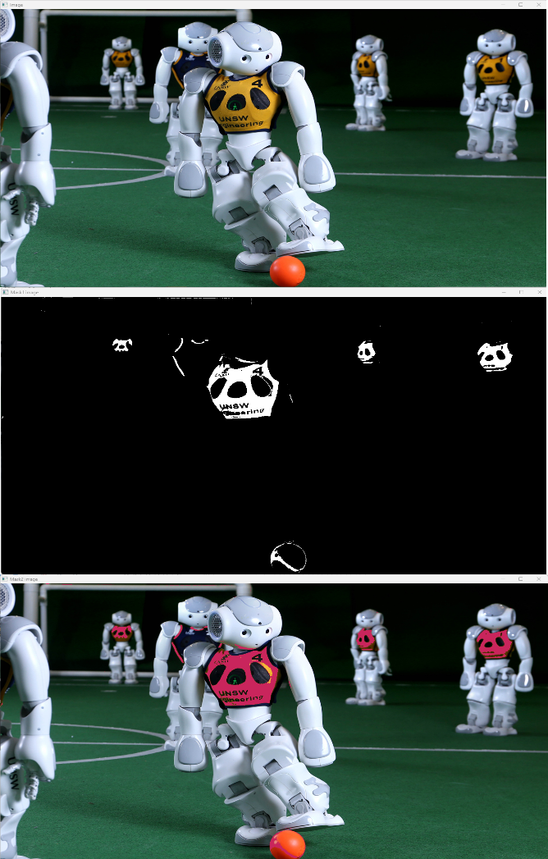

* In the fifth task I did the same as task forth but with HSV image
* In the sixth task I used the all the codes in previous tasks and expanded it to create a new image which is same as the original one in the black areas of the mask and a constant color in the white (chosen) areas.